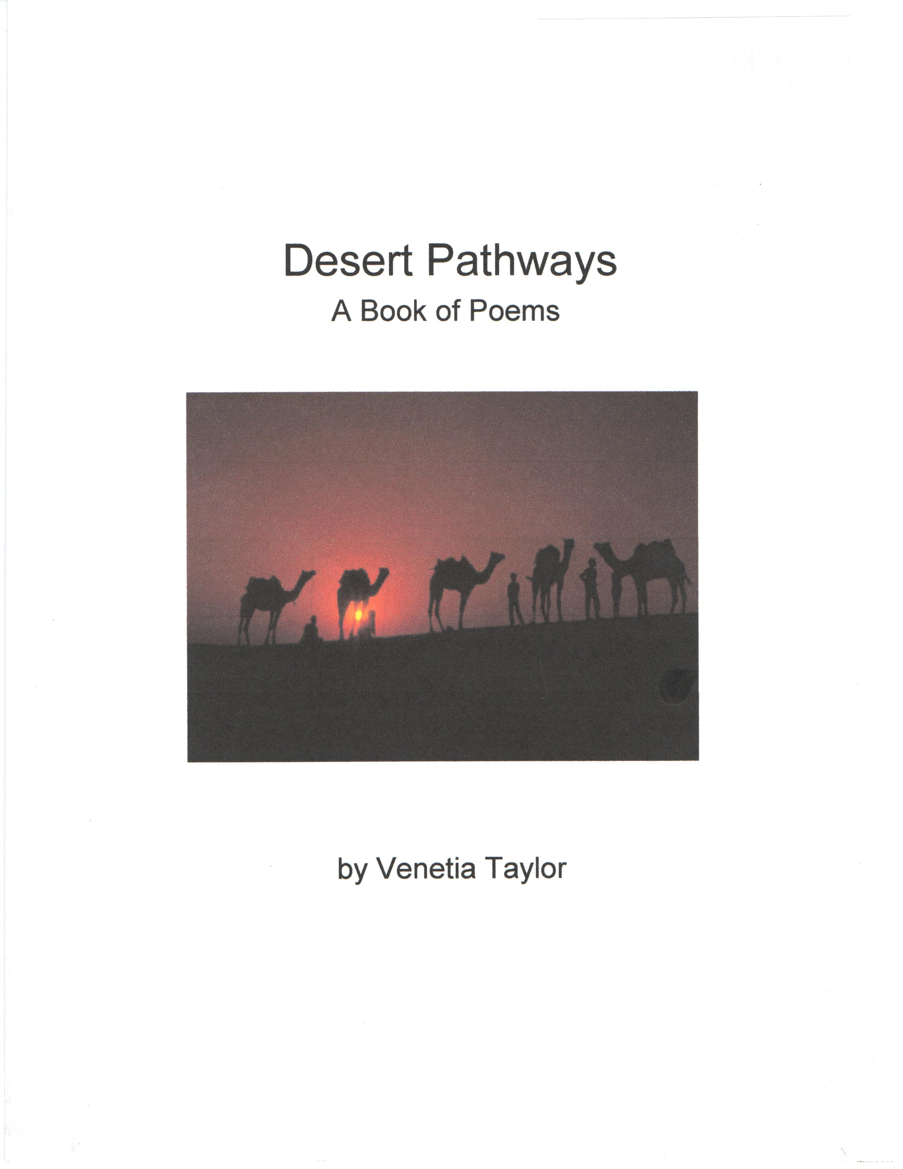

Desert Pathways:
A Book of Poems

by Venetia Taylor
edited by Dick Gibbs

Desert Pathways: A Book of Poems

Copyright © 2011 by Venetia Taylor

Venetia Taylor
P.O. Box 165688
Irving, TX 75016

Self-published in the United States of America

All rights reserved. This volume may not be sold, re-sold, published, or republished, except by the author.

Desert Pathways: A Book of Poems

Table of Contents

Nehemiah 9:19…..……………………………………………………………..………....1

Thank You…..……………….......……………………………………………………….2

Peephole………………………………………………………………………..…………3

Yearning/Conflict……………………………………………....…………………………4

The Mystery………………………………………………………………………………5

Take Me…………………………………………………………...…………….………..6

The Throne of Grace……………………………………………………..….……………7

Be Uprooted……………………………………………………………….…………......8

Building an Altar…………………………………………………………………...……9

A Vision of an Eagle…………………………………………………………….………10

A Whisper…………………………………………...…………………………...………11

Watching Over Me…………………………...……………………………….…………12

The Tear Jar…………………………...…………………………………………………13

Forgiveness…………………………...………………………………………….………14

The Cost…………………………...…………………………………………….………15

Prison Break…………………………...…………………………………...……………16
,
Adora…………………………...……………………………………………….…,……18

Genesis and Exodus…………………………...…………………………………………19

Anointing…………………………...……………………………………………………20

At the Cross…………………………...…………………………………………………21

Walkabout…………………………...………………………………………..…………22

God is in My Dreams…………………………...…………………………….…………23

A Vision of Stars…………………………...…………………………………...………24

Uneclipsable…………………………...……………………………………..…………25

Tears of Intercession…………………………...……………………………….………26

I Am Small…………………………...…………………………………………………27

New Sanctuary…………………………...……………………………………….……28

Speck of dust…………………………...………………………………………………29

Let Yourself be Loved…………………………...…………………………….………30

Hosea 2:14-15…………………………………………………..……...………………31

Desert Pathways:
A Book of Poems



Because of your great compassion you did not abandon them in the desert. By day the pillar of cloud did not cease to guide them on their path, nor the pillar of fire by night to shine on the way they were to take.

Nehemiah 9:19

Thank You

I’ve asked for insight into
What happened that day.
What really took place,
So many years ago?
I’ve looked within myself
To find the reason why.

I was so young.
I thought the man needed help,
When he asked me in.
Everything happened so fast;
I couldn’t call for help.
I wanted to collapse,
I wanted to hide.

But You saw me,
An endangered soul, and You
Covered me with Your protective grace.
You held me close.
Thank You
For preserving my life,
For surrounding my heart.

I wouldn’t change what happened.
It’s made me who I am,
Shaped me.
Thank You
For the sting,
For the change it made in me.

What was meant for bad,
You turned to good.
You took me by the hand,
Healed a little girl, and
Showed me a hurting world.
Thank You
For opening my heart.
.
I’m so thankful
I have this burden…
To love others who are broken.
I know the love I feel is Yours.
I see them through Your eyes, which
Makes me cry.
And I know You cry when I do.
I just want to say
Thank You.

Peephole

Through a peephole
From my inner-most being,
I lifted my eyes to see what was there.
From atop a rocky desert mountain,
Squinting through the peephole,
I saw a city.
I saw a New Jerusalem;
A brilliant light shone there and
There was no need for the sun,
For the Glory of God was the light.
Inside the houses and buildings
I saw a bountiful radiance;
Son-reflectors they were.
I saw special human beings, the chosen ones.
I witnessed there what surely will be,
So why am I still hiding inside of me?
My spirit has yearnings within;
It longs to go home to the City of God,
To lie at the feet of the Kings of Kings.
And then, through the peephole, I saw it.
I now know,
It is not about me.

Yearning/Conflict

How I long to run to You,
To be in Your safe keeping,
To be in the middle of Your design.
I seek Your will,
Yet I am afraid
To feel pain,
Or to be empty.
I know You can
Turn things around,
And I want it,
But I am weak.
I can’t do it.
How I long to be
Wrapped up in You,
Maybe to hide.
Sacrifices are costly,
So can I surrender?
Wait, before You leave,
I’m letting go now.
Even in fear,
I just want You.
The Mystery

Your soul is groaning, my child,
Seeking to interpret the mysteries.
The song I sing over you
Every day is a portion of the Truth, revealed
To you.
When you acknowledge I’m with you,
I sing my Word.
I orchestrated a great symphony,
Still being played, yet not fully heard,
A composition of revelation, and you
Are part of this song.
From creation until the end of this era, even
Before I formed you in my hands,
I imagined you standing before me,
Reflecting my love and glory.
The account of the Garden of Eden
I prepared just for you, with the
Stories of Abraham, Isaac, and Jacob.
When I made my covenant with them,
I was looking at you.
When I guided Moses,
As he led the Israelites
Through the desert and into the promise Land,
I was teaching you lessons.
I was teaching you humility concerning yourself,
And trust toward Me.
The adventures of Ruth, Esther, Joseph, Daniel, and the rest
Were all presented for you.
And then I sent my very best,
My Son,
Who died for you
To redeem you
And all others who accept adoption
And forgiveness of sins.
You’re the chosen one I call Adora.
Your beauty is from me.
Your cries, prayers, desires, and fears
Fill the heavens.
You are called to be set apart.
The lyrics of your song have already been written.
The words are now being intoned over your life.
The mysteries of this music will be fully disclosed,
When the Great Wedding March is played.

Take Me

I see pictures of children flash by,
One by one,
Silent movies,
Untold stories.
They smile bravely;
Their eyes sparkle,
Seemingly full of hope.
But how sad they must be…
Full of heart break.
Their pictures flash on the big screen,
Children flaunted
Like wares
At an auction.
“Take me out of Egypt,”
They seem to say.
“Is there a place for me?”
But even if these beauties
Have no voice,
Their silence screams to me,
“Take me
Out of uncertainty
And into the Promised Land
Of your heart,
Your family,
Your home.
Give me a name.
Give me your love.”

The Throne of Grace

In search of mercy and forgiveness,
Hoping to be purged from sin,
I tiptoe toward Your throne,
With the sin of man in my hand.
I look around me,
Searching for a shadow
In the shape of Your hand,
Hoping for a touch
That feels like patience.
I lie face down in the ashes,
Overwhelmed by my unworthiness.
I moan in the shame of my guilt.
“Woe is me,” I say. “I am unclean.”
I lift up my soul to You.
And You cleanse me through my confession.
I can now enter The Most Holy Place,
Because You have washed me.
I have awoken Your compassion,
Because I have seen that You are God,
And now You will meet me at
The Throne of Grace.

Be Uprooted

With such small faith,
Looking at a great tree,
You know
The odds are stacked against your moving it.
You calculate in your mind
The possible outcome, and
Think perhaps you shouldn’t try.
The uncertainty shows in your shaky voice
As you timidly speak, pray, repent.
But then you are transformed.
The voice of Authority
Shoots out from within you
Like a powerful ray of light,
Blasting through doubt and hesitation.
A command comes forth,
“Be uprooted and planted in the sea!”
And it is.

Building an Altar

I come to build an altar
Out of my brokenness.
Even though I’m weak,
I hope to build it
From the pieces of my life.
I build this altar to You,
And on this altar
I lay down
Every element of my heart,
Past, present, and future,
Dreams and insecurities,
Awards and failures.
It is here I exchange
My nothing for Your everything.
Helpless, I lay silent
In Your presence,
Tears streaming down my face.
With no claim of deservedness,
I receive Your love and acceptance,
And my heart is full.
At last, I see that
The altar is not my handiwork, after all,
But Yours.
You are the builder of this altar.
I can only lie upon it,
To worship and treasure You.

A Vision of an Eagle

I hear the sound of an Eagle
Singing from somewhere on high.
Soaring above the earth,
I hear him scream.
I spot this majestic Eagle,
Strongest of all birds.
I watch Him fly away
Over the mountain tops,
Touching the farthest reaches of the sky.
Through the clouds,
I mark the sound
Of an Eagle singing.

Isaiah 40:31
…those who hope in the LORD will renew their strength. They will soar on wings like eagles; they will run and not grow weary, they will walk and not be faint.

A Whisper

A whisper
You speak
To draw me in
Close enough
To hear You.
And You
Whisper softly
Into me,
“Be at home.
Dwell in
My body.
I am
Your temple.”
I feel You near.
Father,
Daughter,
Whispering.
Feels like
Butterflies
On my cheek,
Butterflies
Inside of me.
This is from You.
Not thunder,
But a whisper.

Watching Over Me

Watch over me
And help me know my destiny.
Many choices I must make,
Many roads I must take.
Growing up came so fast;
Time and chances soon slid past.

I seem further and further behind
As others move so quickly.
Watch over me;
Living is hard, and
I am not up to the task.
There is much to do and I haven’t even started.

Are You watching?
Empty hands I raise to You.
I have done so little.
I am on my knees,
Yet my world is spinning away.
Will there be time enough?

What is my life?
I ponder the thorn in my side,
How it lingers…and stings.
I want to know where I belong,
Or where I need to be.
Please continue watching over me.

I long for the place that’s made for me.
Tears of yearning fall from my eyes.
I am on my knees again,
Reaching out, hoping You will take my hand.
Then, as fear and doubt arise once more,
I give thanks that You never sleep,

Because You are watching over me.

The Tear Jar

Bottled up are my tears,
Reflections of the years.
Recorded are the steps
Of my life as I wept.
Like stars in a constellation,
Gathering and scattering and shining,
My tears are collecting in a jar, illuminated
In the hands of The Most High.
With vigilance, he keeps the jar safe,
Stored where no one can harm it.
And each time new tears flow,
He meets me in the secret place
Where hurting hearts go.
He holds His jar to catch my tears, until
It is filled to the brim
With seeds of sadness that must be sown
To reap glad hearts of joy.
I am comforted…
Knowing my tears are noticed.
I am uplifted…
Knowing the jar is treasured.

Forgiveness

To the One who knew me before I was,
Who created me in the darkness of my mother’s womb,
Who knew my name and the color of my eyes,
I lift up my soul, my spirit, my body.
There is nothing about me that I can hide from You.
I am naked.
I am exposed.
So shine Your light into my darkness to disclose my shame,
And I will confess it.
And when You hear it, You will forgive.
I am in pieces, but
It is Your hand that puts me back together.
I am blind, but
It is Your lips that kiss my eyes to give me sight.
I am alone, but
I feel Your arms around me.
Your heart beats within my chest;
Your tears roll down my cheeks;
Your smile beams from my face.
But when I walk away to sin,
And know that I have stepped back from You,
The heaviness comes,
Consumes the air…
I cannot breathe
Without You

Near.

The Cost

Before you say, “I do,” or proclaim, “Here I am; send me,”
Have you counted the cost of eternity?
If you were a rich young ruler, would you sell all you have to be a follower?
If you were a fisherman or a tax collector, would you leave your job and family and just go?
Would you trade Saul for a Paul?
Would you lay down your Isaac on the altar?
Would you leave Egypt to wander forty years in the dessert?
Would you sacrifice pride?
Would you relinquish power?
Would you lose Your sight?
Would you endure torture?
Would you accept a fate like Stephen, John the Baptist, or Peter?
Did you count the cost to follow Jesus?
To live is Christ, to die is gain.
It may cost you everything.
He counted the cost long ago, and
Found us worth redeeming.
The cost was His pure blood.
His Father’s cost was His only Son.
He paid the price.
Will you?
Prison Break

I stand alone in my cell,
Locked up, chained.
The prison guards glower and mock,
Making hideous noises.
Their faces are filled with pleasure,
As they observe me ensnared.
Still smiling in their eyes,
They move me
To an appointed place.
They are enthralled at my despair.
It is hopeless.

What is this?
Above their celebration,
I hear my name called softly, in
The voice of an Angel, who has come
To minister.
At first I refuse it, yet
The calling of my name pulls me.
Why is my name being called?
Am I going to be set free?
No.
Surely,
I am a dead man walking.

But in a moment,
Something awakens
Within the depths of me.
I am confessing,
Repenting,
Crying.
And I see…
I am holding the key.

Yet, here is
My destiny before me,
The chair
Of life’s ending,
Death’s beginning.
Suddenly, I feel
A million lightning bolts
Raging through me.
Then, it is over.

And for the first time,
I can see
The Lord of Lords,
The King of Kings.
I look back
At my body,
Limp and lifeless
In the chair
Behind the prison walls.

And then I look at God and bow
In awe at His grace.
He has redeemed a recalcitrant,
And
I am making
The greatest prison break
Of all time.

I was lost;
Now I’m found.
Was blind;
But now I see.
Many prisoners
Roam the earth,
Bound and hopeless,
Chained by iniquity.
But the blood of Christ
Was shed
To set these captives free.

Adora

Adora,
My beloved…
I see the tears raining down from your heart,
Though your eyes are dry.
I hear the cries you sing in the night,
Though all around you is soundless.
I know your mind is restless,
While you imagine stillness.
I see you
hoping
I’m near.
Let my light pierce through
your darkness.
Let My love
Consume you,
Adora,
My love.

Genesis and Exodus

I am from dust,
Molded by strong hands,
Given the breath of life,
Birthed by God.
Born a human,
I tread the earth
With sweat on my brow,
Full of mortal pain.
I work the fields.
I learn the laws.
I play.
I rest.
I marry.
I fight.
I reconcile.
I walk the earth.
Contemplating my end,
I notice the earth’s dust on my feet.
I stop to take it in.
I came from dust,
And I will go,
But not the way I came.
I go not to dust;
I go to God.

Anointing

Beautiful jar of destiny,
Filled with expensive perfume,
Sprinkle down on me.
Anoint me with oil
To set me apart and dedicate me
To the King.
Anoint me to anoint Him.
We see in Scripture
One weeping at His feet,
A woman, a sinner,
Washing away His tears
With kisses and perfume,
Anointing the Man
Who anointed her with forgiveness.
Anointing…fall on me
To prepare me for this King.

At the Cross

I am lying at the cross,
Humbled by the blood
And broken skin.
Here You offer salvation
From my sin.
Faith is welcome here, so
It’s where I begin

I kneel at the cross,
With empty hands
And an open heart,
Humbled by the love
Of God, now man,
Awed at the gift
Of the slaughtered Lamb.

I weep at the cross,
And seek the
Great I Am.
I praise the One
Who forgives my sin, and
Give thanks that He embraces
And cleanses me.

Lying at the cross
Again,
I remember where I died,
And where I came to life again in Him.
This is where He came to live in me,
Because it was finished
At the cross.

Walkabout

I am journeying through a rite of passage,
Where, in spiritual adolescence,
I trace the paths of the patriarchs
From long ago.
Through my own wilderness of sin and death,
I am shedding dead flesh.
I scream.
I cry.
I often wonder why,
Or what the reason might be for the pain.
Yet, imperceptibly,
I am maturing,
Gaining wisdom through
A walkabout with Jesus.
There is no other way
To live
With Yahweh.
So go on…
Take another step
On this walkabout,
This journey;
It is the way home.

God is in My Dreams

In the middle of the night,
In the depths of my dreams,
In many pictures moving,
There I find Your love for me.
As I lie alone in the dark,
Your hand blankets me;
As I sleep,
Your touch assures me.
Then right before dawn,
With first light rising,
I hear Your voice whisper,
“I am with You.”
I awaken, and
There You are,
Filling the eyes of my heart,
Smiling at me.

A Vision of Stars

In the second heaven,
Standing next to
The Great One
I saw the Son
Robed in light.
I saw a formless star
Cupped in His hands.
I heard His voice,
Telling me how it was made.
He called it by name.
Then I looked out
And I saw…
Millions, billions of stars
Shining in the dark.
They have names,
And He knows them all.

Uneclipsable

Who or what could ever eclipse You, Lord?
No one and no thing.
You are Creator of heaven and earth,
The reason for my reason.
No sun, moon, star, or galaxy,
No kingdom,
No currency,
No army,
No country,
No space or time,
And no name,
Is greater.
No one’s words are more powerful,
No thought,
No deed,
No status,
No thing.
You are from everlasting to everlasting.
Without Your approval Satan can’t exist,
Nor can all created things.
Who or what could ever truly eclipse You, Lord?
I don’t desire to eclipse You;
I desire to reflect You.

Tears of Intercession

Drip, drop,
Salty water falls, as
A moan is uttered, and
The Spirit roars.
Heaven is
Swaying, rocking
Like a tree that is
Moved by the wind.
Prayer is power,
When the Spirit has full course
In a willing vessel.

I Am Small

When I consider Your heavens,
The work of Your hands,
The moon and the stars
That You have set in place,
And then I discover that
You know them by name, I must ask,
Who am I that You are mindful of me?
Who are people that You care for them?
You made them a little lower than heavenly beings,
Crowned them with glory and honor, and
Made them rule over the works of Your hand.
When I consider the scene of Your creation,
And see how You placed me in it
As dust of the ground,
I am assured that
It was Your own breath that formed me and
Transformed me to match Your image,
And gave me life.
Now when I am still and see my own emptiness,
And my nearly infinitesimal smallness,
And as I stand before Your fullness and power and
Witness Your everlasting completeness,
I know a thing to be true:
I am becoming invisible, because
I’m disappearing into You.

New Sanctuary

A glorious Throne exists in heaven,
exalted from the beginning,
While a sanctuary abides in me.
From the sanctuary,
To the throne,
Confession flows like a river, and
Sin is carried
From my heart, to my lips, to You.
You burn it up; sear from my heart all my sin.
The heart is deceitful above all things
And beyond cure.
Who can understand it?
You, Lord, search my heart and examine my mind
To reward me according to my purity.
Heal me, Lord, and I will be healed.
Forgive me, and I will be forgiven.
I praise You.
I thank You.
I long to know You.
I will be still and meditate on You,
Disclosing to You all I am, all I desire, all I fear,
So You can cleanse me,
And restore me to holiness.
May I disappear in Your glory, and reflect You,
Present to You a pure offering, a new sanctuary.
I bare my heart to the Great I Am.
I lift up my soul to You.

Speck of Dust

A tiny grain,
A particle of the earth
In the palm of Your hand.
A speck I am,
A speck of dust,
To be blown away by the wind.
In Your hand I find myself
Breathing in the breath of life,
From Your lungs into mine.
You make my chest rise with breath.
You make my heart beat.
You open my eyes and now I see this
Speck of dust,
And know,
Without You I am nothing.

Let Yourself be Loved

What have you done that’s so bad?
What have you seen?
What have you heard?
Who told you that I wouldn’t love you?
Let yourself be loved.
Open up to me.
I’m waiting at the door
To embrace you.
Let yourself be loved.
Open up to me.
I’ll remove the illusions that blind you;
I’ll expose the lies that delude you.
Open up to me,
And listen carefully.
It doesn’t matter what you’ve done.
I’ll show you a new way to see.
I’ll whisper to you a new way to hear.
I’ll love into you a way
To let yourself be loved.
Just take the focus off of you
And see the love in Me.

I will win her back once again. I will lead her
out into the desert and
speak tenderly
to her there.

I will return her vineyards to her and
transform the Valley of Trouble
into a gateway
of hope.

Hosea 2:14-15

